South Dakota State Fire School
2024 Schedule
Most events will be at the Lake Area Technical College (LATC), 1201 Arrow Avenue
*schedule may be subject to change; be aware of updates *

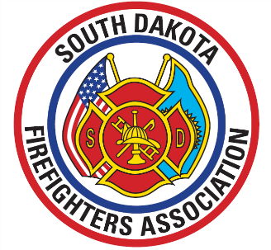
Thursday, June 13th
9:00 – 3:00 – Tradeshow set-up – LATC Student Services Center (SSC)
3:00 -- Registration & Vendor Show open
5:30 – Registration & Vendor Show closes
5:30 -- Instructor Meeting – LATC (TBA)
6:00 – Water fights & Evolutions (5:30 sign-up) Downtown Watertown
Supper on your own – 3rd St SE, E Kemp Ave intersection

Friday, June 14th
7:00 -- Registration Opens – LATC
7:30 – Opening Remarks & Membership Meeting – LATC SSC Events Center
8:00 – Tradeshow Opens
8:30 – Classes begin
After 11:30 -- Dinner – (schedule may vary by class) – food on-site – SSC Commons
1:00 – Classes Resume after dinner
5:00 – Registration and Tradeshow Closes
5:30 – Firefighters Memorial Service – LATC Events Center
Supper on your own
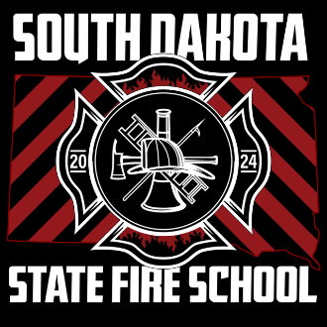
Saturday, June 15th
7:30 – Registration & Vendor Show Opens
8:30 - Classes Begin
11:00 – Election polls open
After 11:30 – Dinner –
12:00 -- Tradeshow closes
1:00 – Classes resume after dinner
2:00 – Election polls close
Upon completion of last class – Closing Ceremonies / Membership meeting / Awards
LATC Events Center (approx. 430pm )




