SDFA Fall Fire Conference Schedule
AmericInn Hotel Conference Center
29 Sept – 1 Oct 2023 - Fort Pierre, SD
All times Central Standard Time

Friday 29 September
- 8:30am–12:00pm SDFA Board of Directors meetings
- 1:00pm–3:30pm Joint Council of Emergency Services Mtg – Conference Center
- 5:00pm–7:00pm Registration at AmericInn Conference Center
- 6:00pm-8:00pm Meet and Greet Sponsored Social (hors d'oeuvres & cash bar) at Conference Center
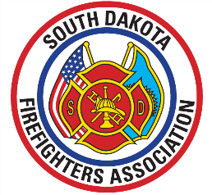
Saturday 30 September
- 8:00am Registration
- 9:00am-10:30am General Membership Meeting & Discussions
- 10:30am-10:45am Break
- 10:45-1200pm Conference Speakers - Sessions

Jeff Dill: An Internal Size-Up
An in-depth FF/EMT behavioral health workshop dedicated to educating attendees on the awareness of stress, anxiety, PTSD, addictions, depression, anger, suicide and retirement.
Jeff Dill: Saying Goodbye: An Emotional Detachment
This course is designed to prepare fire and EMS personnel about the emotional aspects of retirement. Overcoming feelings of loss of identity, loss of belonging and lack of purpose.

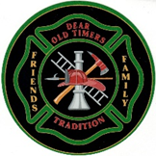
- 12:00pm-1:00pm Dinner – (included with your registration)
- 1:00pm-2:30pm Conference Center – Sessions Continue
- 2:30pm-2:45pm Break

2:45pm-5:00pm Conference Speaker Sessions continue
- 530pm-? Dear Old Timers & Conference Social

Sunday 1 October
- 8:00am–9:00am Continental Breakfast (included with your registration)
- 9:00am-10:30am Conference Center – Final Session and Membership Discussions
- Dinner – On Your Own
- 2:00pm Annual Fallen Firefighter Memorial Service – Memorial Site at Capitol Lake/Rotunda




